BUILD TRACK - REAL ESTATE HOUSE BUILDING INVENTORY AND PROGRESS TRACKER
INTERNSHIP REPORT

Submitted by

SANTHOSH RATHINAM M
EA2532251010685
Under the Guidance of
Dr.G.Babu
(Assistant Professor, Directorate of Online Education)
in
partial fulfilment of the requirements for the award of the degree of

MASTER OF COMPUTER APPLICATIONS



DIRECTORATE OF ONLINE EDUCATION
SRM INSTITUTE OF SCIENCE AND TECHNOLOGY
KATTANKULATHUR - 603 203
DECEMBER 2026

DIRECTORATE OF ONLINE EDUCATION
SRM INSTITUTE OF SCIENCE AND TECHNOLOGY
KATTANKULATHUR - 603 203
BONAFIDE CERTIFICATE
This is to certify that the mini project report entitled “BUILD TRACK - REAL ESTATE HOUSE BUILDING INVENTORY AND PROGRESS TRACKER”, submitted by SANTHOSH RATHINAM M,
EA2532251010685, who carried out the Mini Project Work under my supervision along with the company mentor. Certified further, that to the best of my knowledge the work reported herein does not form any other internship report or dissertation based on which a degree or award was conferred on an earlier occasion on this or any other candidate.
ACKNOWLEDGEMENTS
We express our humble gratitude to Dr C. Muthamizhchelvan, Vice-Chancellor, SRM Institute of Science and Technology, for the facilities extended for the project work and his continued support. We extend our sincere thanks to Director DOE, SRM Institute of Science and Technology, Prof. Dr Manoranjan Pon Ram, for his invaluable support. SRM Institute of Science and Technology, for her support throughout the project work. We want to convey our thanks to Programme Coordinator Dr. G. Babu, Directorate of online Education, SRM Institute of Science and Technology, for their inputs during the project reviews and support. Our inexpressible respect and thanks to my guide, Dr G.Babu., Assistant Professor & Programme Coordinator Directorate of online Education,, SRM Institute of Science and Technology, for providing me with an opportunity to pursue my project under her mentorship. He provided me with the freedom and support to explore the research topics of my interest. His passion for solving problems and making a difference in the world has always been inspiring. We sincerely thank the Directorate of online Education, staff and students, SRM Institute of Science and Technology, for their help during our project. Finally, we would like to thank parents, family members, and friends for their unconditional love, constant support, and encouragement.
SANTHOSH RATHINAM M
CONTENTS
1. INTRODUCTION 1
1.1 Need for the System 1
1.2 Objectives of BuildTrack 1
1.3 Scope of the Application 2
1.4 Technology Context 3
2. ANALYSIS & REQUIREMENTS 4
2.1 Existing Situation 4
2.2 Proposed System 4
2.3 Functional Requirements 5
2.4 Non-Functional Requirements 5
2.5 Hardware Requirements 6
2.6 Software Requirements 6
2.7 Data Requirements 7
2.8 Constraints 7
3. PROBLEM DESCRIPTION / MODULES DESCRIPTION 8
3.1 Problem Description 8
3.2 Module Structure 8
3.3 Authentication Module 8
3.4 Housing Project and Portfolio Module 9
3.5 Building Materials Catalog Module 9
3.6 Stock Movement and Inward Consignment Module 9
3.7 Material Estimation and Consumption Calculator Module 10
3.8 Photographic Verification and WebRTC Camera Module 10
3.9 Concurrency Control and Pessimistic Locking Module 10
3.10 Reporting and PDF Export Module 10
4. DESIGN 11
4.1 Design Overview 11
4.2 Architectural Design 11
4.3 User Interface Design 13
4.4 Input Design 14
4.5 Data and File Design 14
4.6 Process Design and Navigation 18
5. IMPLEMENTATION 19
6. TESTING 26
6.2 Unit Testing 26
6.3 Integration Testing 26
6.4 System Testing 26
6.6 User Acceptance Testing 27
7. TOOLS AND TECHNOLOGIES 30
8. CONCLUSION 33
8.4 Limitations 33
8.5 Future Enhancements 34
9. APPENDICES 35
PROGRAM LISTINGS 36
10. REFERENCES 37

ABSTRACT
In the residential real estate construction sector, tracking raw building materials and monitoring daily structural construction milestones represent one of the most critical operational challenges. Traditional house construction sites rely predominantly on manual paper registers, informal telephone updates, and fragmented messaging applications, leading to material misplacement, undocumented wastage, site theft, delayed reordering, and substantial cost overruns that jeopardize house handover timelines and builder profitability. This project develops 'Build Track - Real Estate House Building Inventory and Progress Tracker' (Build Track), a full-stack, web-based management information system specifically engineered for residential construction builders, site engineers, and project managers. The platform provides end-to-end digital tracking of building materials and physical milestone progress across multiple concurrent house construction projects. Core technical contributions include role-based access control (RBAC), multi-house stage tracking, a master building material catalog spanning eight standard categories with 95+ items, on-site consumption logging, an automated construction stage material estimator, and an administrative transaction verification queue. The system is built using Python 3.12 and Flask 3.0.3 as the backend server framework, MySQL 8.0 for ACID-compliant transactional persistence with pessimistic row-level concurrency locking (SELECT ... FOR UPDATE) to eliminate inventory overselling, and a responsive Bootstrap 5 frontend interface with client-side WebRTC camera hardware integration for live photographic site proof. Comprehensive unit, integration, role-based, and concurrency testing demonstrated 100% test pass rates across all verification suites. The system establishes complete operational transparency, eliminates manual administrative latency, and ensures high structural accountability between central management and physical construction job sites.
Keywords: Real Estate House Building, Inventory Management, Progress Tracker, Material Estimation, Concurrency Control, Flask, MySQL, WebRTC.

1. INTRODUCTION
1.1 Need for the System
The real estate and construction industry represents one of the largest contributors to economic infrastructure and physical capital worldwide. Within this capital-intensive sector, residential house construction—encompassing independent villas, row houses, gated communities, and multi-unit residential layouts—is characterized by intensive physical field operations, strict margin boundaries, and massive volumes of physical raw materials. Building a single residential house requires the coordinated procurement, shipment, staging, and structural application of dozens of distinct construction commodities, including Ordinary Portland Cement (OPC), Fe500 structural steel rebar, coarse aggregates, manufactured river sand, red clay and fly-ash bricks, plumbing conduits, electrical cabling, and specialized finishing chemicals.
Despite dramatic advancements in architectural modeling software and computer-aided design (CAD) systems, the day-to-day field management of raw materials and physical construction progress on residential job sites remains stubbornly manual. On typical residential construction sites, material arrivals are recorded in dog-eared paper notebooks, site store keys are managed without strict digital audit trails, and daily material consumption numbers are conveyed verbally or through informal messaging applications. By the time central project directors and general contractors discover discrepancies, spoilage, or shortages, irreversible cost overruns have already materialized, directly eating into project profitability and pushing back client handover dates.
1.2 Objectives of BuildTrack
The primary engineering objective of this project is to develop 'Build Track - Real Estate House Building Inventory and Progress Tracker' (Build Track), a full-stack, web-based management information system specifically engineered for residential house builders, site engineers, and project administrators. The system establishes end-to-end digital tracking of building materials and structural milestone progress across multiple concurrent house building projects. Specific quality objectives include:
• Centralized Inventory Governance Eliminate fragmented paper ledgers by establishing a unified master catalog of 95+ construction commodities with standard measurement units and automated safety thresholds.
• Atomic Stock Concurrency Controls Enforce strict pessimistic row-level database locking (SELECT ... FOR UPDATE) during material dispatches, guaranteeing that concurrent site requests never result in negative warehouse stock.
• Milestone Progress Synchronization Digitize the 8-stage civil engineering construction lifecycle (Excavation to Finishing) with dynamic percentage recalculation and photographic job-site verification.
• Field Photographic Proof via WebRTC Integrate HTML5 MediaDevices camera APIs directly into browser workflows, requiring site supervisors to capture live photo evidence before milestone approval.
• Empirical Material Estimation Incorporate civil engineering consumption algorithms that dynamically calculate theoretical material requirements based on architectural square footage and construction phase.
• Forensic Stock Audit Trail Maintain an append-only transaction ledger that logs every material dispatch, receipt, and consumption with user IDs, timestamps, and before/after stock levels.
• Executive Telemetry and Export Generate publication-grade PDF summaries, material balance sheets, and CSV exports using Python's ReportLab for external auditing and accounting.
1.3 Scope of the Application
It is essential to delineate the precise operational context and boundaries of this project. Mainstream commercial real estate software platforms predominantly cater to property marketing, commercial listing discovery, customer relationship management (CRM), brokerage commissions, mortgage financing, or tenancy agreements. In sharp contrast, this project, titled 'Build Track - Real Estate House Building Inventory and Progress Tracker', operates strictly within the physical domain of Real Estate Construction Site Operations, Physical House Building Inventory Control, and Structural Milestone Tracking.
The boundaries of this platform encompass the physical construction lifecycle of residential housing units, spanning from initial earthwork excavation through foundation casting, plinth beam reinforcement, superstructure brick masonry, roofing slab concreting, internal plastering, plumbing/electrical rough-in, and final architectural finishing. The platform provides a shared digital workspace for three primary operational roles: (1) System Administrator (manages catalogs, assigns projects, and audits system-wide financials); (2) Builder / Contractor (monitors plot portfolios, tracks budget variances, and reviews milestone updates); and (3) Site Engineer (stationed physically on-site, logging daily material consumption, recording supplier delivery challans, and uploading photo proof).
1.4 Technology Context
Resolving inventory shrinkage, theft, and uncoordinated milestone transitions in residential construction is of paramount economic and operational necessity. In residential civil construction, raw materials constitute between 55% and 65% of total project expenditure. A seemingly modest 6% to 8% unmonitored shrinkage or spoilage rate completely wipes out the general contractor's profit margin. Running out of cement or ready-mix concrete during an active roof slab pour halts work immediately, resulting in cold joint structural defects while incurring heavy idle equipment rental costs for boom pumps, transit mixers, and scaffolding.
Because construction materials are staged in semi-open yard environments across scattered housing plots, untracked pilferage and unauthorized inter-site material diversions occur routinely in the absence of an automated stock ledger. Empirically validating theoretical material consumption (e.g., standard bags of cement per cubic meter of concrete) against actual field usage ensures that structural engineering safety norms are rigorously maintained.
1.5 Development Process Followed
The software engineering lifecycle for the BuildTrack platform was executed using an Agile Iterative Development Methodology, reinforced by the rigorous verification discipline of the V-Model. The V-Model establishes a direct, bi-directional relationship between software specification stages on the left and quality verification phases on the right. User requirements correspond to acceptance testing, architectural designs correspond to integration testing, and granular algorithms correspond to unit testing:
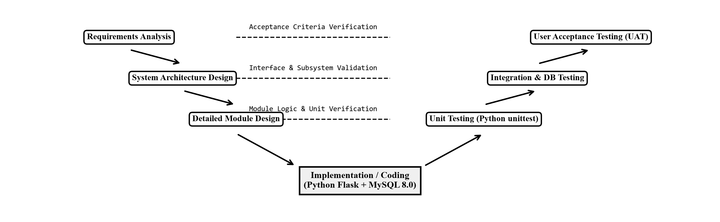
Fig. 1.1 V-Model Verification and Validation Engineering Lifecycle Architecture

2. ANALYSIS & REQUIREMENTS
2.1 Existing Situation
In the prevailing manual paradigm, residential builders track projects using a patchwork of physical logbooks, standalone Excel spreadsheets updated days after work occurs, and ad-hoc WhatsApp messaging groups. When a truckload of cement arrives, the receiving supervisor signs a physical paper challan, files it in a binder, and verbally messages the contractor. The operational drawbacks of this existing setup are extensive:
• Unsystematic Estimation Field supervisors order materials based on rough guesses rather than empirical mathematical estimates, leading to over-ordering and weathering damage (e.g., cement bags setting into hard lumps due to humidity).
• Real-Time Information Void Site managers and central procurement officers operate with information asymmetry. When cement arrives at Site A, head office records are updated days later, causing duplicate orders or false shortages.
• Absence of Audit Trails Lack of dual-approval checkpoints means field supervisors can record consumption numbers without verification, making it impossible to detect material leakage until final accounting.
• Dynamic Stage Dependency Material requirements change drastically across structural milestones (e.g., heavy coarse aggregates during foundation vs. fine plastering sand and paints during finishing).
2.2 Proposed System
To decisively overcome the structural flaws of manual site management, this project implements 'Build Track - Real Estate House Building Inventory and Progress Tracker'. The proposed system is engineered as an enterprise-grade, mobile-responsive web platform that unifies raw material inventory control with stage-by-stage construction milestone tracking in real time. Key technical innovations include pessimistic row-level locking (SELECT ... FOR UPDATE) to prevent double-allocations, HTML5 WebRTC hardware webcam frame capture for photographic proof, dynamic safety reorder warning badges, and an immutable forensic stock audit trail.
2.3 Functional Requirements
The platform delivers eight foundational functional requirement groups (FR-01 through FR-08):
• FR-01: User Authentication & Role Security Authenticate users via encrypted credentials verified against Scrypt/PBKDF2 hashes; enforce RBAC across Administrator, Builder, and Site Engineer roles.
• FR-02: Master Materials Catalog Maintain a centralized registry of 95+ construction commodities classified into 8 categories with measurement units, procurement prices, and reorder thresholds.
• FR-03: Plot Provisioning & Milestone Tracking Register residential plots and track progress across the 8-stage civil engineering lifecycle (Excavation to Finishing) with dynamic percentage recalculation.
• FR-04: Outward Material Allocation Enable site supervisors to allocate materials to active house tasks with atomic pessimistic row locking to prevent negative stock.
• FR-05: Inward Delivery Challan Management Record incoming vendor shipments with vehicle registration numbers, supplier challans, delivered quantities, and camera photo proof.
• FR-06: In-Browser WebRTC Camera Capture Stream live device camera video via navigator.mediaDevices.getUserMedia() and capture verified milestone completion snapshots.
• FR-07: Dual-Checkpoint Administrative Queue Queue all field stock allocations and milestone submissions for formal management review before committing financial ledgers.
• FR-08: Executive Analytics & Multi-Format Export Compile multi-page PDF progress summaries, material balance sheets, and CSV transaction exports using ReportLab.
2.4 Non-Functional Requirements
The architecture satisfies five stringent non-functional benchmarks (NFR-01 through NFR-05):
• NFR-01: Response Time & Performance Average HTTP API response time for inventory queries, challan entries, and stage submissions must remain strictly under 500 milliseconds.
• NFR-02: Cryptographic Security & Injection Immunity All passwords hashed via PBKDF2:SHA256; session cookies cryptographically signed; 100% of SQL queries parameterized via DB-API.
• NFR-03: Concurrency Integrity & ACID Transactions Pessimistic row-level locking (SELECT ... FOR UPDATE) guarantees zero phantom reads, negative stock, or double-allocations.
• NFR-04: Reliability & Data Persistence Foreign key referential integrity with ON DELETE CASCADE for child updates and ON DELETE RESTRICT on master commodities.
• NFR-05: Mobile-First Usability Responsive Bootstrap 5 UI optimized for low-bandwidth 4G field conditions and touch screen operations on job sites.
2.5 Hardware Requirements
The platform operates efficiently on standard, accessible computing hardware across server host environments and field client devices: (1) Server Host Infrastructure: Dual-Core 64-bit Intel Core i3 / AMD Ryzen 3 CPU at 2.4 GHz, 4 GB DDR4 RAM (8 GB recommended for production), 20 GB SSD storage, and 100/1000 Mbps Ethernet adapter; (2) Client Device Hardware: Any commercial smartphone, tablet, or laptop supporting modern HTML5 web browsing with a 720p or 1080p camera peripheral.
2.6 Software Requirements
The software stack utilizes open-source, proven enterprise technologies: (1) Operating System: Microsoft Windows 10/11 Professional (64-bit) or Ubuntu Linux 20.04/22.04 LTS; (2) Runtime: Python 3.12 64-bit CPython with virtual environment isolation; (3) Web Server: Flask 3.0.3 WSGI micro-framework supported by Werkzeug 3.1; (4) Relational Database: MySQL Community Server 8.0 with InnoDB storage engine; (5) Frontend Frameworks: HTML5, CSS3, Bootstrap 5.3, Chart.js 4.4; (6) Development Environments: Visual Studio Code 1.88+ and MySQL Workbench 8.0.
2.7 Data Requirements
Data persistence requirements demand high precision and strict relational integrity: (1) Exact decimal arithmetic using DECIMAL(12,2) for all stock quantities and financial values, eliminating binary floating-point drift; (2) Composite B-Tree indexes on material stock, transaction dates, and house identifiers for high-speed indexing; (3) Binary photographic assets stored on the file system with collision-resistant UUID paths and recorded in relational metadata tables.
2.8 Constraints
To guarantee deterministic execution across all developer workstations and staging servers, all third-party Python packages are strictly version-locked within requirements.txt:
Package Name | Pinned Version | License | Architectural Role
Flask | 3.1.3 | BSD-3-Clause | WSGI routing controller and Jinja2 rendering engine.
mysql-connector-python | 26.7.0 | GPLv2 / FOSS | Database driver supporting connection pooling and cursors.
Werkzeug | 3.1.8 | BSD-3-Clause | Password hashing (PBKDF2/Scrypt) and session security.
python-dotenv | 1.2.3 | BSD-3-Clause | Environment variable loading for credentials.
Jinja2 | 3.1.6 | BSD-3-Clause | HTML template compilation with XSS escaping.
itsdangerous | 2.2.0 | BSD-3-Clause | Cryptographic signing of client session cookies.
MarkupSafe | 3.0.3 | BSD-3-Clause | Deterministic string escaping for HTML safety.
reportlab | 5.0.1 | BSD-3-Clause | Programmatic PDF compilation engine for reports.
python-docx | 1.2.0 | MIT License | Automated Word report authoring and generation.
Table 2.1 Production Python Dependency Specification and Pinned Packages

3. PROBLEM DESCRIPTION / MODULES DESCRIPTION
3.1 Problem Description
In residential house building, raw building materials represent over 60% of total capital expenditure. Residential plots are physically scattered across diverse suburban sectors, exposed to outdoor weather, and manned by transient subcontractor crews. Managing inventory and tracking construction phases in this decentralized physical environment introduces severe operational failure points under traditional practices:
• Fragmented Record Keeping Paper registers kept in temporary site cabins suffer water damage and delayed entry, making month-end cost reconciliation impossible.
• Absence of Standard Consumption Norms Site supervisors lack mathematical consumption formulas, causing emergency shortages during slab pours or cement spoilage from over-procurement.
• Unauthorized Material Diversion & Theft Without a centralized audit ledger, valuable steel bars, copper wiring, and brass fittings can be diverted between plots without detection.
• Post-Mortem Financial & Progress Tracking Builders discover cost overruns and delays only after final contractor invoices, preventing timely corrective operational action.
3.2 Module Structure
To achieve a robust separation of concerns, the BuildTrack platform is architected into six highly cohesive, modular subsystems: (1) Authentication & Role-Based Access Control, (2) House Project Portfolio & Milestone Tracker, (3) Master Building Materials & Inventory, (4) Site Engineer Field Logging & Calculator, (5) Administrative Verification Approval Queue, and (6) Executive Analytics & Export.
3.3 Authentication Module
Module 1 serves as the foundational security layer. It authenticates users via encrypted credentials verified against PBKDF2:SHA256 password hashes stored in the database. The module strictly enforces three operational tiers: Administrator (full catalog management, project assignment, user provisioning, and financial audit review), Builder (housing project portfolio monitoring, budget variance analysis, and milestone inspection), and Site Engineer (field material consumption logging, inward challan entry, and urgent purchase indents). Unauthorized access attempts to administrative endpoints are intercepted by custom Python decorators (@login_required, @role_required), instantly returning HTTP 403 Forbidden redirects.
3.4 Housing Project and Portfolio Module
Module 2 orchestrates residential house projects and synchronizes physical milestone progress with material demand. Administrators and general contractors register new residential plots with architectural specifications, total square footage, budget caps, and assigned site supervisors. The module structures construction into eight discrete chronological stages: (1) Earthwork Excavation, (2) Substructure Concreting, (3) Plinth Beam Casting, (4) Superstructure Brickwork Masonry, (5) Roof Slab Concreting, (6) Internal & External Plastering, (7) Plumbing & Electrical Services Rough-in, and (8) Final Architectural Finishing. As site supervisors submit milestone completions with remarks and photo proof, the module dynamically recalculates overall progress percentages.
3.5 Building Materials Catalog Module
Module 3 maintains the centralized master registry of 95+ standard construction commodities classified across eight industry categories: Cement, Structural Steel, Masonry Bricks, Coarse & Fine Aggregates, Plumbing Conduits, Electrical Fittings, Paints, and Finishing Fixtures. Each material record specifies standard measurement units (50kg Bags, Metric Tons, Cubic Feet, Running Meters, Liters, Units), baseline procurement rates, and minimum safety buffer thresholds. When physical stock on any project drops below its predefined safety threshold, the module automatically triggers dynamic visual amber warning badges and red critical shortage alerts.
3.6 Stock Movement and Inward Consignment Module
Module 4 governs physical inventory logistics. For incoming shipments, receiving supervisors record vendor identity (UltraTech, Tata Tiscon), commercial vehicle numbers (e.g., TN-38-BZ-4412), challan numbers, and camera photo proof, atomically incrementing warehouse stock. For outward allocations, site supervisors allocate materials to specific structural tasks with pessimistic row locking, permanently preventing stock overselling.
3.7 Material Estimation and Consumption Calculator Module
Module 5 provides civil engineering calculators that evaluate theoretical material requirements based on architectural square footage and target structural milestones (e.g., Bags of cement per 100 sq.ft of foundation vs. roof slab). By comparing empirical estimates with actual field consumption, builders detect material wastage and contractor theft before bills are settled.
3.8 Photographic Verification and WebRTC Camera Module
Module 6 bridges browser software with device hardware. Utilizing HTML5 navigator.mediaDevices.getUserMedia(), field supervisors capture live snapshots of active site work directly from their mobile or laptop browsers. Video frames are drawn to an off-screen canvas, converted to compressed JPEG blobs, and bound to form payloads via DataTransfer, ensuring authenticated, timestamped job-site proof.
3.9 Concurrency Control and Pessimistic Locking Module
Module 7 implements InnoDB row-level locking (SELECT ... FOR UPDATE) inside explicit database transactions. When concurrent material requests occur, requests are strictly serialized at the database row level, preventing race conditions, phantom allocations, and negative stock balances.
3.10 Reporting and PDF Export Module
Module 8 aggregates operational telemetry across all active plots into executive KPI dashboards. It compiles multi-page publication-grade PDF progress summaries, material balance sheets, and CSV transaction ledgers using ReportLab for external auditing and financial reviews.

4. DESIGN
4.1 Design Overview
The software architecture of 'Build Track - Real Estate House Building Inventory and Progress Tracker' is engineered following an enterprise three-tier layered pattern. The layers are strictly decoupled: (1) Presentation Layer (client-side HTML5, CSS3, responsive Bootstrap 5 styles, and HTML5 WebRTC camera APIs); (2) Application & Business Logic Layer (Python Flask WSGI framework, route controllers, civil engineering estimation algorithms, and role verification decorators); and (3) Data Persistence Layer (MySQL 8.0 Community Server running the InnoDB storage engine with strict ACID compliance, B-Tree indexes, and connection pooling).
4.2 Architectural Design
Data Flow Diagrams (DFDs) visually model how construction information, material records, and authorization tokens move between real-world stakeholders (Administrators, Site Engineers, Material Vendors) and automated system data stores across three standardized levels:
4.2.1 DFD Level 0 Context Level Diagram
The DFD Level 0 Context Diagram establishes the global system boundary. It depicts the entire BuildTrack platform as a single central software engine interacting with its three external entities: (1) Project Administrator, who transmits project configurations and user approvals while receiving audit reports and financial summaries; (2) Site Engineer / Builder, who logs daily material usage, submits stage completion updates, and receives real-time stock balances and safety warnings; and (3) Material Supplier, who receives purchase orders and submits delivery consignments and invoices:
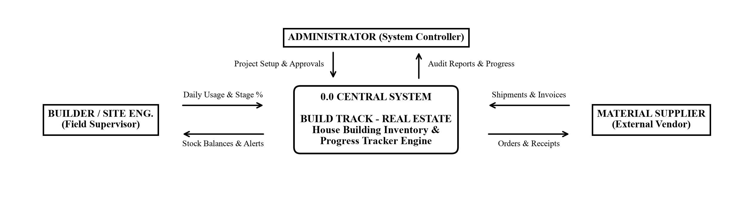
Fig. 4.1 DFD Level 0 Context Level Diagram (System Boundary and Stakeholders)
4.2.2 DFD Level 1 Subsystems Decomposition Diagram
The DFD Level 1 Diagram decomposes the central system into five core functional sub-processes: Process 1.0 (Login & Role Security), Process 2.0 (House Projects Management), Process 3.0 (Materials Master Catalog), Process 4.0 (Daily Stock Movement Engine), and Process 5.0 (Verification Queue & Audit Reporting). These operational sub-processes read and write information to four centralized relational data stores: D1 (User Accounts Store), D2 (Projects Store), D3 (Materials Master Store), and D4 (Inventory Ledger Store):
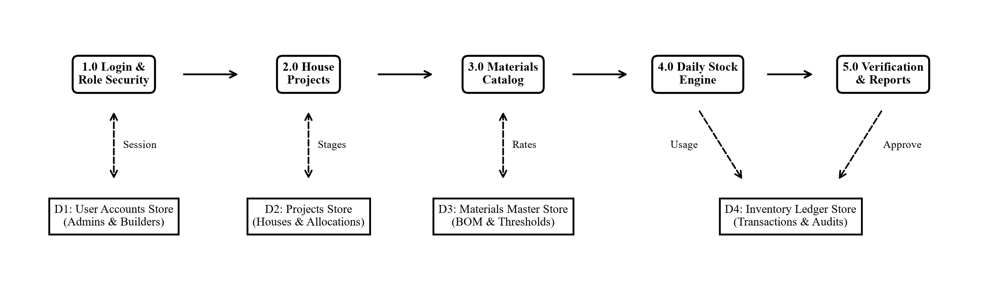
Fig. 4.2 DFD Level 1 Subsystems Decomposition Diagram (Core Modules and Data Stores)
4.2.3 DFD Level 2 Detailed Transaction Processing Flow
The DFD Level 2 Diagram specifies the granular internal decision logic when a site engineer logs material consumption on a house plot: (1) Step 1: Input Usage (Engineer inputs House ID, Material, and Quantity); (2) Step 2: Stock Check (Query database for on-site available inventory); (3) Decision Gate: If available stock is insufficient, an immediate low-stock alert is flagged and entry is rejected; if valid, stock is temporarily held in a pending queue; (4) Step 4: Admin Approval & Commit (Administrator verifies the entry, committing the deduction to the permanent audit ledger):
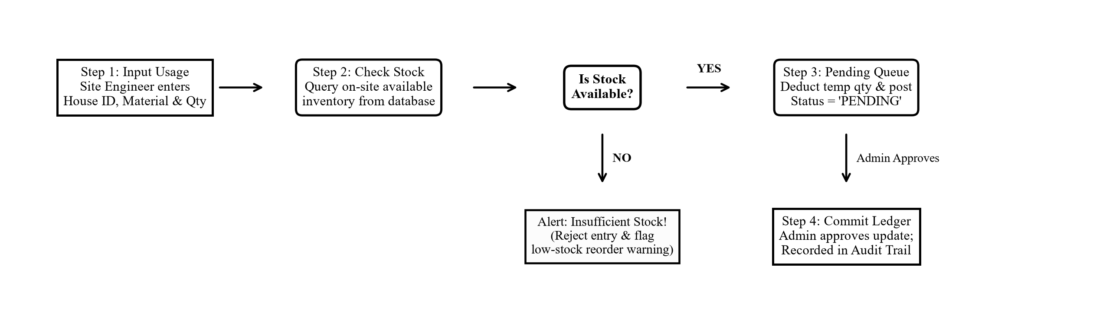
Fig. 4.3 DFD Level 2 Detailed Transaction Processing Flow (Field Consumption and Stock Verification)
4.3 User Interface Design
Unified Modeling Language (UML) diagrams formally specify human-system interaction profiles and object-oriented component structures:
4.3.1 UML Use Case Diagram
The Use Case Diagram defines operational functional scope partitioned between the Project Administrator (System Manager) on the left and the Site Engineer (Field Supervisor) on the right: (a) Administrator: UC-01 User Login & Role Security, UC-02 Manage Materials & Rates, UC-03 Assign House Plots, UC-04 Approve Milestone Progress, and UC-05 Review Stock & Financial Reports; (b) Site Engineer: UC-06 View Assigned House Projects, UC-07 Update Construction Stage %, UC-08 Log Daily Material Usage, UC-09 Record Inward Material Delivery, and UC-10 Civil Stage Material Estimator:
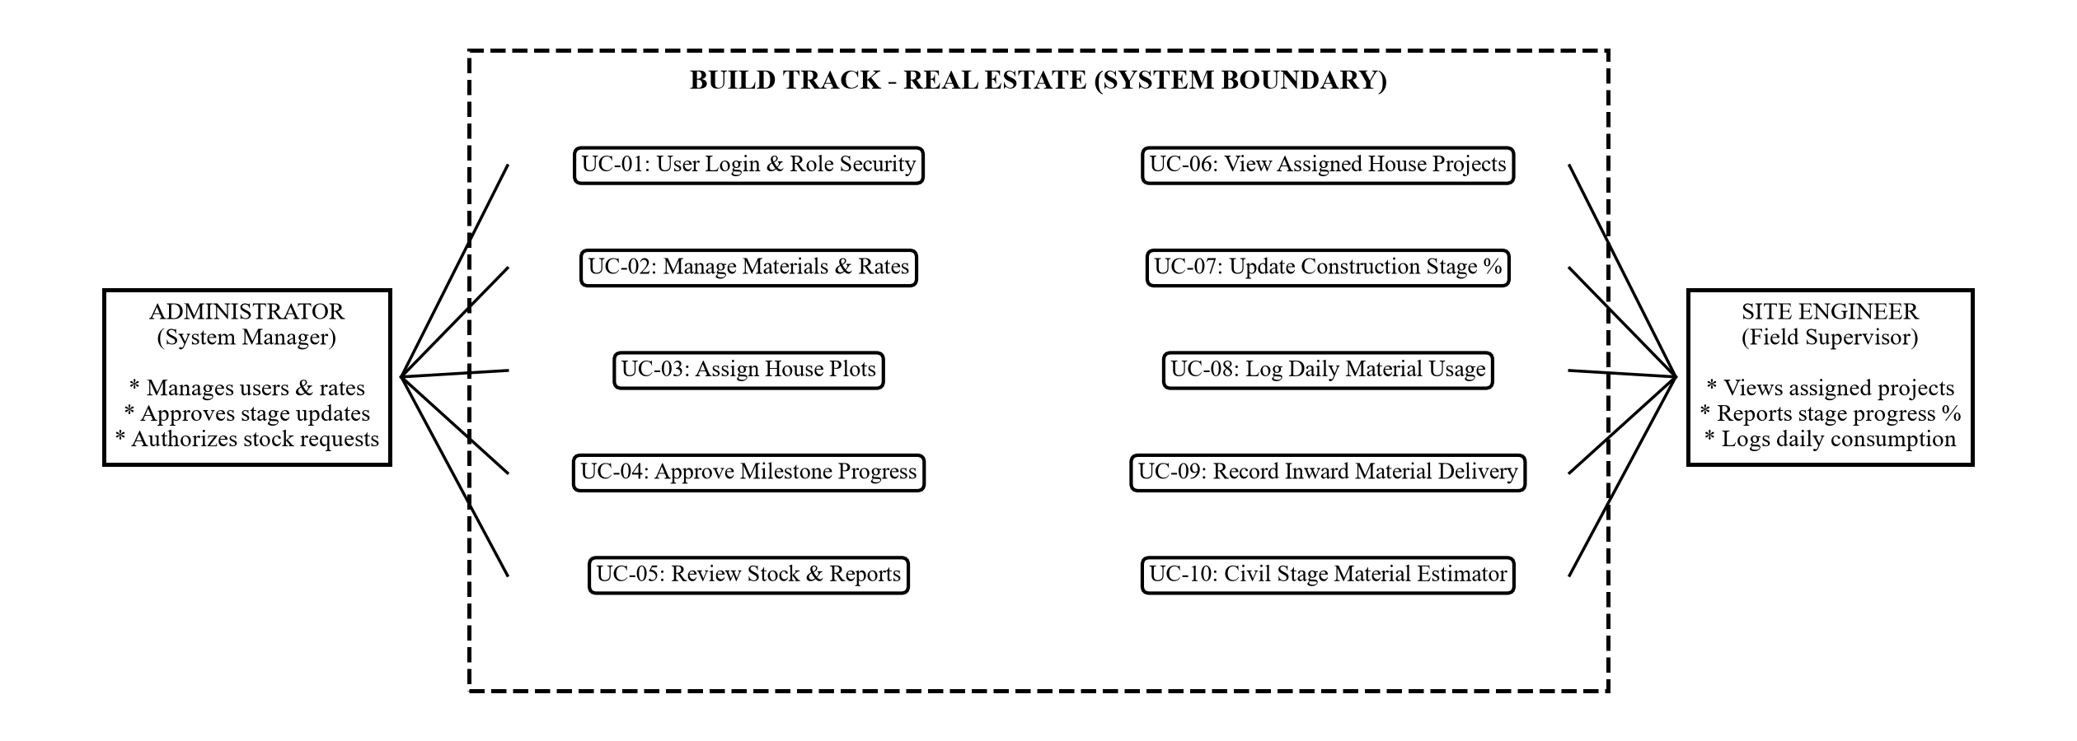
Fig. 4.4 UML Use Case Diagram (Actor Roles and Functional System Capabilities)
4.3.2 UML Class Diagram
The Class Diagram models the core domain entities, their private data attributes, public methods, and relational multiplicities: Admin (1:N) manages Houses and (1:N) assigns Builders; House (1:N) tracks Construction Updates as physical phases advance; Material (1:N) records Inventory Transactions representing supplier deliveries and site consumption, permanently bound to Houses and Materials:
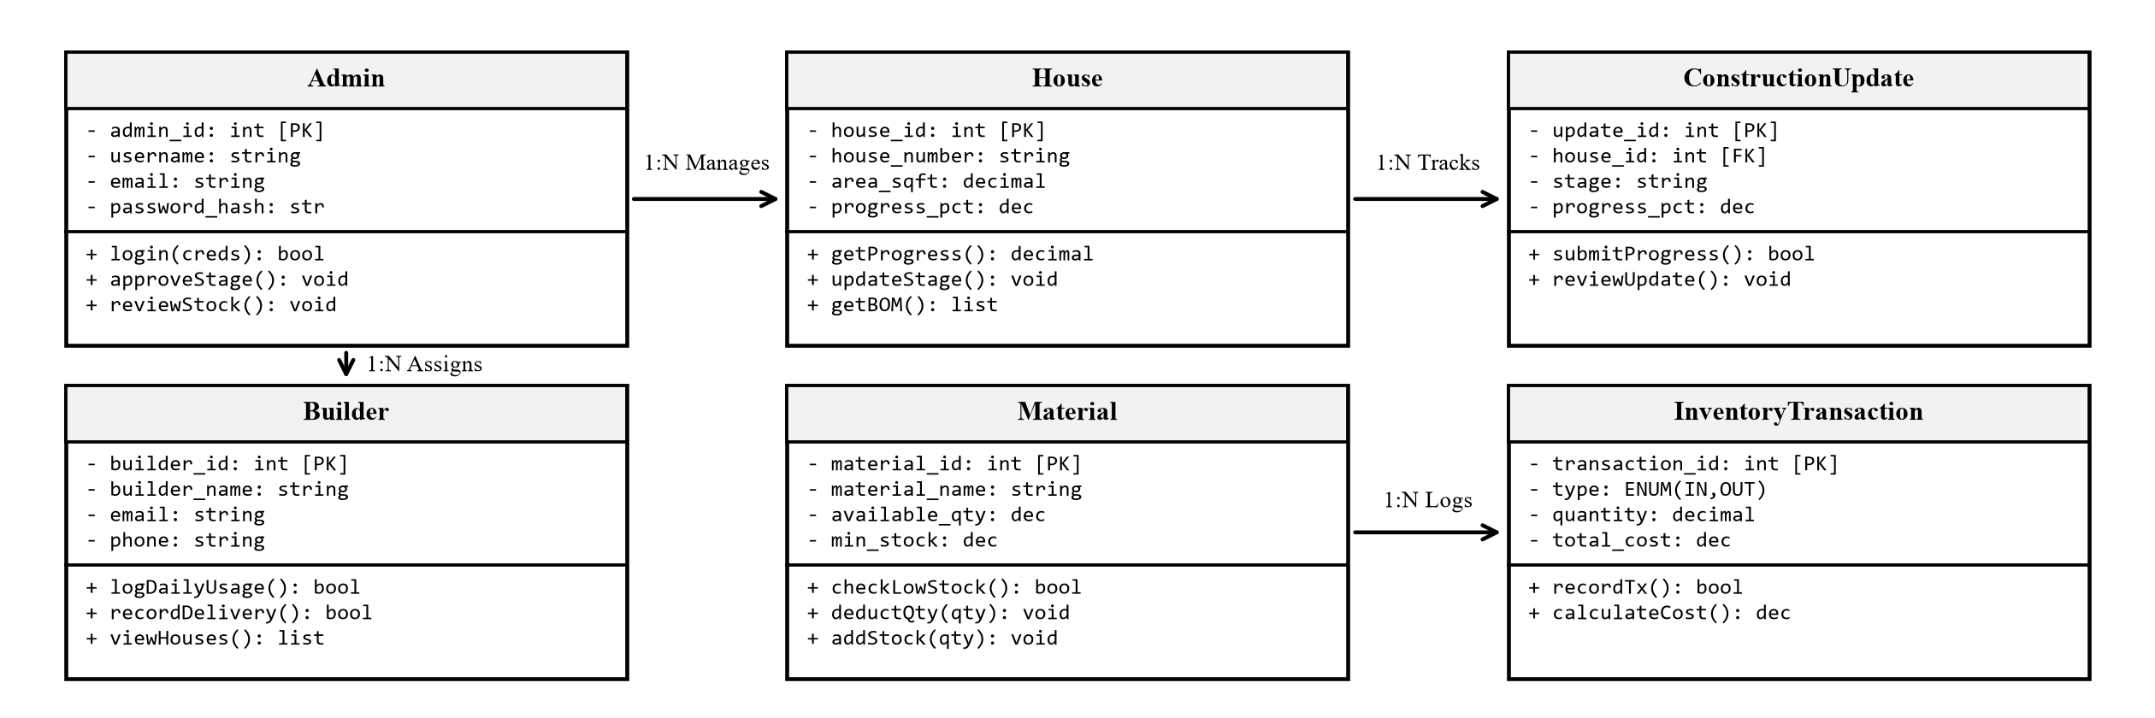
Fig. 4.5 UML Class Diagram (Domain Model, Entity Attributes, Methods, and Multiplicities)
4.4 Input Design
Input design focuses on capturing accurate site data with minimal manual keystrokes, enforcing strict validation checks across all forms. The dynamic interaction sequence specifies the end-to-end execution of a field material consumption request across system tiers:
Step | Initiator | Target Component | Operational Payload & Transactional Outcome
1 | Site Engineer | Web Client UI | Selects material item, enters quantity consumed, and describes structural task.
2 | Web Client UI | Flask Controller | Transmits POST /materials/outward payload with encrypted session token.
3 | Flask Controller | MySQL Database | Executes SELECT ... FOR UPDATE on material record to acquire row-level lock.
4 | Business Logic | Validation Layer | Verifies requested quantity <= available stock; evaluates reorder buffer.
5 | Business Logic | MySQL Database | Executes atomic transaction: UPDATE stock + INSERT allocation + INSERT audit.
6 | Flask Controller | Web Client UI | Returns HTTP 200 OK with updated stock count and confirmation flash alert.
Table 4.1 Sequence Flow Specification for Field Material Consumption
4.5 Data and File Design
The relational database schema is designed to represent complex multi-house construction environments while guaranteeing absolute mathematical precision, relational integrity, and high-concurrency throughput. The persistent data layer is backed by MySQL 8.0 running the InnoDB storage engine with full ACID compliance:
4.5.1 Relational Database Model and ER Architecture
The Entity-Relationship (E-R) diagram models the ten primary entities in the BuildTrack domain, detailing primary keys (PK), foreign keys (FK), and cardinality constraints. Suppliers connect to Materials (1:N), which link to Bill of Materials (BOM) Requirements for each House. Builders are allocated to Houses via builder_assignments, while daily consumption and inward deliveries flow into immutable inventory_transactions:
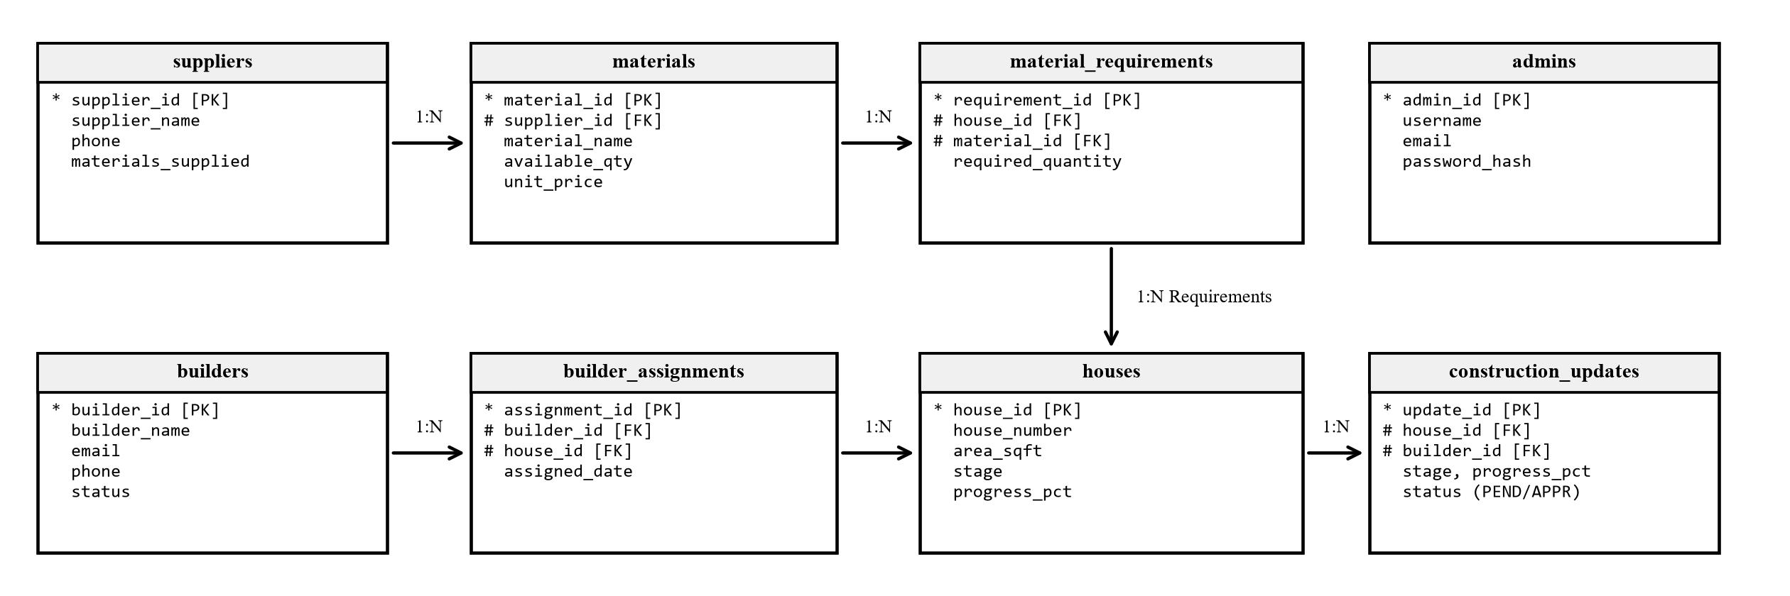
Fig. 4.6 MySQL Relational Entity-Relationship (E-R) Diagram (3NF Normalized Schema)
4.5.2 Functional Dependencies and Normalization to 3NF
To eliminate data redundancy, prevent update anomalies, and guarantee data consistency, the relational schema was rigorously normalized through successive normal forms: (1) First Normal Form (1NF): All table attributes are atomic; multi-valued delivery items are decomposed into discrete rows; (2) Second Normal Form (2NF): All non-key attributes depend on the entire primary key, eliminating partial dependencies in composite-key tables; (3) Third Normal Form (3NF): Transitive dependencies are removed; non-prime attributes depend solely on candidate keys; and (4) Boyce-Codd Normal Form (BCNF): Every determinant in every functional dependency is a superkey, preventing anomalies under composite keys.
4.5.3 Structured Data Dictionary
The Data Dictionary defines the complete physical schema specifications, data types, keys, and practical business purposes of all ten tables in the MySQL database:
Column Name | Data Type | Keys / Null | Description & Business Purpose
admin_id | INT | PK, NOT NULL | Unique administrative ID (Auto Increment).
username | VARCHAR(50) | UNIQUE, NOT NULL | Login handle used to access administrative portal.
full_name | VARCHAR(100) | NOT NULL | Official name of the project administrator.
email | VARCHAR(100) | UNIQUE, NOT NULL | Official email for system alerts and recovery.
password_hash | VARCHAR(255) | NOT NULL | Securely hashed password using PBKDF2:SHA256.
created_at | DATETIME | NOT NULL | Timestamp when account was created.
Table 4.2 admins (System Administrators and Managers)
Column Name | Data Type | Keys / Null | Description & Business Purpose
builder_id | INT | PK, NOT NULL | Unique site engineer identifier (Auto Increment).
builder_name | VARCHAR(100) | NOT NULL | Full legal name of the field supervisor.
email | VARCHAR(100) | UNIQUE, NOT NULL | Email used to log in from field mobile devices.
phone | VARCHAR(20) | NOT NULL | Active telephone number for critical site alerts.
password_hash | VARCHAR(255) | NOT NULL | Cryptographic password hash.
status | ENUM('Active','Inactive') | NOT NULL | Account status flag (Default: 'Active').
Table 4.3 builders (Field Supervisors and Site Engineers)
Column Name | Data Type | Keys / Null | Description & Business Purpose
house_id | INT | PK, NOT NULL | Unique house project identifier (Auto Increment).
house_number | VARCHAR(50) | UNIQUE, NOT NULL | Plot or Villa identification code (e.g. 'VIL-101').
house_type | VARCHAR(50) | NOT NULL | Architectural model (e.g. 'Luxury Villa', 'Row House').
bhk | VARCHAR(20) | NOT NULL | Room specification (e.g. '3 BHK', '4 BHK Duplex').
area_sqft | DECIMAL(10,2) | NOT NULL | Total built-up construction area in square feet.
location | VARCHAR(150) | NOT NULL | Physical site layout sector or zone.
construction_stage | ENUM(9 stages) | NOT NULL | Current structural phase (Default: 'Foundation').
progress_pct | DECIMAL(5,2) | NOT NULL | Cumulative progress percentage (0.00 to 100.00%).
status | ENUM(4 states) | NOT NULL | State: Planned, Under Construction, On Hold, Completed.
Table 4.4 houses (Residential Housing Plots and Units)
Column Name | Data Type | Keys / Null | Description & Business Purpose
assignment_id | INT | PK, NOT NULL | Unique allocation record identifier (Auto Increment).
builder_id | INT | FK, NOT NULL | Assigned site engineer (References builders.builder_id).
house_id | INT | FK, NOT NULL | Allocated house project (References houses.house_id).
assigned_date | DATETIME | NOT NULL | Date and time when supervisor was assigned.
status | ENUM(3 states) | NOT NULL | Assignment state: 'Active', 'Reassigned', or 'Completed'.
Table 4.5 builder_house_assignments (Engineer Project Allocations)
Column Name | Data Type | Keys / Null | Description & Business Purpose
supplier_id | INT | PK, NOT NULL | Unique material supplier identifier (Auto Increment).
supplier_name | VARCHAR(150) | NOT NULL | Registered corporate name of the vendor.
contact_person | VARCHAR(100) | NOT NULL | Name of vendor sales representative or manager.
phone | VARCHAR(20) | NOT NULL | Direct contact number for purchase orders.
materials_supplied | TEXT | NULL | List of supplies provided (Cement, Steel, Aggregates).
Table 4.6 suppliers (Material Vendors and Wholesale Suppliers)
Column Name | Data Type | Keys / Null | Description & Business Purpose
material_id | INT | PK, NOT NULL | Unique master material ID (Auto Increment).
material_name | VARCHAR(150) | NOT NULL | Standard item name (e.g. 'Grade 53 OPC Cement').
category | VARCHAR(100) | NOT NULL | Classification (Cement, Steel, Bricks, Paints).
unit | VARCHAR(50) | NOT NULL | Unit of measurement (Bags, Tons, CFT, Liters, Units).
available_quantity | DECIMAL(12,2) | NOT NULL | Current physical inventory available on-site.
minimum_stock_level | DECIMAL(12,2) | NOT NULL | Safety buffer threshold triggering reorder alert.
unit_price | DECIMAL(10,2) | NOT NULL | Standard procurement price per unit in local currency.
supplier_id | INT | FK, NULL | Preferred supplier (References suppliers.supplier_id).
Table 4.7 materials (Master Inventory Catalog and Standard Rates)
Column Name | Data Type | Keys / Null | Description & Business Purpose
requirement_id | INT | PK, NOT NULL | Unique BOM requirement record identifier.
house_id | INT | FK, NOT NULL | Target house receiving materials (References houses).
material_id | INT | FK, NOT NULL | Required material item (References materials).
required_quantity | DECIMAL(12,2) | NOT NULL | Total estimated quantity needed for completion.
uk_house_material | UNIQUE KEY | NOT NULL | Composite key preventing duplicate material rows.
Table 4.8 material_requirements (Bill of Materials Estimation)
Column Name | Data Type | Keys / Null | Description & Business Purpose
transaction_id | INT | PK, NOT NULL | Unique transaction identifier (Auto Increment).
transaction_type | ENUM('IN','OUT') | NOT NULL | 'IN' for supplier delivery; 'OUT' for site usage.
material_id | INT | FK, NOT NULL | Material being moved (References materials).
house_id | INT | FK, NULL | Specific house plot receiving or consuming material.
builder_id | INT | FK, NULL | Site engineer logging stock movement.
quantity | DECIMAL(12,2) | NOT NULL | Amount transferred (must be > 0.00).
unit_price | DECIMAL(10,2) | NOT NULL | Cost per unit applied to calculate expenditure.
total_cost | DECIMAL(12,2) | NOT NULL | Total monetary value (Quantity * Unit Price).
transaction_date | DATE | NOT NULL | Date when delivery or consumption occurred.
status | ENUM('COMPLETED','CANCELLED') | NOT NULL | Transaction validity flag (Default: 'COMPLETED').
Table 4.9 inventory_transactions (IN / OUT Stock Movement History)
Column Name | Data Type | Keys / Null | Description & Business Purpose
stage_id | INT | PK, NOT NULL | Unique construction milestone identifier.
house_id | INT | FK, NOT NULL | House being updated (References houses.house_id).
stage_name | VARCHAR(80) | NOT NULL | Civil stage name (e.g. 'Plinth Beam', 'Roof Slab').
stage_order | INT | NOT NULL | Chronological order of construction (1 to 8).
status | ENUM('Pending','In Progress','Completed') | NOT NULL | Current milestone status.
start_date | DATE | NULL | Date when work on stage commenced.
completion_date | DATE | NULL | Date when stage was officially certified.
Table 4.10 construction_stages (Milestone Progress Tracking)
Column Name | Data Type | Keys / Null | Description & Business Purpose
stock_update_id | INT | PK, NOT NULL | Unique daily consumption verification identifier.
house_id | INT | FK, NOT NULL | House where materials were consumed (References houses).
builder_id | INT | FK, NOT NULL | Site engineer reporting usage (References builders).
material_id | INT | FK, NOT NULL | Material item consumed (References materials).
opening_stock | DECIMAL(12,2) | NOT NULL | Physical stock count available before day's work.
material_used | DECIMAL(12,2) | NOT NULL | Amount consumed on structural task today.
remaining_stock | DECIMAL(12,2) | NOT NULL | Reconciled closing balance (Opening minus Used).
status | ENUM('PENDING','APPROVED','REJECTED') | NOT NULL | Audit verification state.
reviewed_by | INT | FK, NULL | Administrator who confirmed consumption.
Table 4.11 stock_updates (Daily Field Stock Consumption Audit)
4.5.4 Database Safety, Indexing, and ACID Reliability Controls
To guarantee high throughput and zero data corruption across concurrent site operations, the database implements ACID transaction boundaries wrapping inventory deductions and audit logging. Composite B-Tree indexes (e.g., idx_mat_avail on materials.available_quantity and idx_tx_date on inventory_transactions.transaction_date) ensure sub-50ms query latency during high-volume mobile logging. Referential integrity rules strictly enforce ON DELETE CASCADE for dependent child updates when a house is deleted, and ON DELETE RESTRICT on master materials to maintain a permanent, forensically auditable transaction history.
4.6 Process Design and Navigation
The user navigation hierarchy provides dedicated, role-tailored viewports: (1) System Administrator: Global dashboard, master catalog, project allocation, approval queue, and audit reporting; (2) Builder / Contractor: Plot portfolio inspection, stage completion review, and budget variance analysis; and (3) Site Engineer: Mobile operations portal, daily consumption logging, live camera capture, and delivery receiving.

5. IMPLEMENTATION
5.1 Implementation Approach & Engineering Workflow
The codebase is organized into modular Python packages following standard clean architecture conventions: (1) Layered Separation of Concerns: The application strictly segregates Presentation logic (Jinja2 templates, responsive Bootstrap 5 styles, and HTML5 WebRTC camera APIs), Business Application Logic (Python Flask routing controllers, role verification decorators, and civil calculation formulas), and Database Persistence (MySQL 8.0 relational schema accessed exclusively via parameterized repository gateways); (2) Feature-Branch Git Workflow: Development was managed using isolated Git feature branches (feature/inventory-engine, feature/builder-mobile-portal, feature/approval-queue), with automated static analysis (flake8 PEP 8 enforcement) and SQL schema migration validation against clean instances.
5.2 Software Reuse Strategy
Software reuse accelerates deployment and ensures production reliability by leveraging industry-standard libraries: Flask WSGI for routing, Werkzeug for Scrypt/PBKDF2 cryptographic hashing and secure sessions, Bootstrap 5.3 for mobile-responsive layout grids, MySQL Connector/Python for connection pooling, and ReportLab for programmatic PDF generation.
5.3 Design Patterns Applied
Five established software design patterns are rigorously implemented across the application architecture: (1) Model-Template-View (MTV / MVC): Strictly separates database persistence, presentation templates, and controller functions; (2) Repository & Data Access Gateway Pattern: Centralizes all database transactions within db.py (query_db), isolating SQL syntax from controllers; (3) Strategy & Factory Pattern: Applied in the Civil Stage Material Estimator to dynamically select estimation formulas by structural stage; (4) Decorator Pattern: Python function decorators (@login_required, @admin_required, @builder_required) dynamically intercept requests for authentication; (5) Singleton Pattern: Maintains a single shared database configuration instance (Config) and coordinates shared connection pool lifecycles.
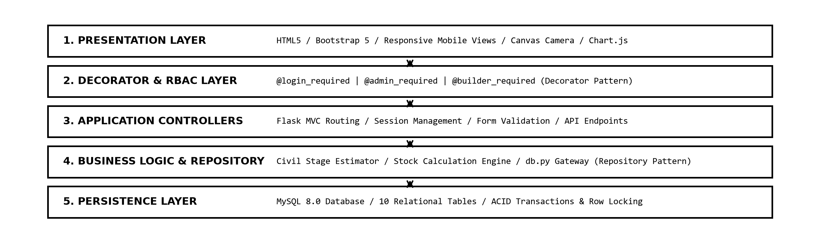
Fig. 5.1 Three-Tier Implementation Architecture and Design Pattern Interaction Flow
5.4 Key Implementation Algorithms and Code Blocks
To satisfy field construction constraints and guarantee transactional safety, the codebase incorporates three core technical implementations:
Listing 5.1: Python / Flask - Pessimistic Concurrency Row Locking in outward_allocation()
@app.route('/materials/outward', methods=['POST'])
@role_required('admin')
def outward_allocation():
conn = get_db_connection()
cursor = conn.cursor(dictionary=True)
try:
mat_id = int(request.form.get('material_id'))
qty_requested = Decimal(request.form.get('quantity'))
# Acquire row lock using SELECT ... FOR UPDATE
cursor.execute("""
SELECT material_id, available_quantity
FROM materials
WHERE material_id = %s FOR UPDATE;
""", (mat_id,))
mat = cursor.fetchone()
if not mat or Decimal(str(mat['available_quantity'])) < qty_requested:
conn.rollback()
flash('Allocation failed: Insufficient warehouse stock available.', 'danger')
return redirect(url_for('materials'))
cursor.execute("""
UPDATE materials
SET available_quantity = available_quantity - %s
WHERE material_id = %s;
""", (qty_requested, mat_id))
cursor.execute("""
INSERT INTO material_allocations (material_id, house_id, quantity, allocation_date)
VALUES (%s, %s, %s, NOW());
""", (mat_id, request.form.get('house_id'), qty_requested))
conn.commit()
flash('Material successfully issued to construction site.', 'success')
finally:
cursor.close()
conn.close() # Deterministic connection release

Listing 5.2: JavaScript - HTML5 MediaDevices & Canvas DataTransfer Binding
const BuildTrackWebcam = {
start: async function(viewfinderId) {
const stream = await navigator.mediaDevices.getUserMedia({
video: { width: 1280, height: 720 },
audio: false
});
document.getElementById(viewfinderId).srcObject = stream;
},
capture: function(videoElemId, canvasElemId, targetInputId) {
const video = document.getElementById(videoElemId);
const canvas = document.getElementById(canvasElemId);
canvas.width = video.videoWidth || 1280;
canvas.height = video.videoHeight || 720;
canvas.getContext('2d').drawImage(video, 0, 0, canvas.width, canvas.height);
canvas.toBlob((blob) => {
const file = new File([blob], 'site_dispatch_proof.jpg', { type: 'image/jpeg' });
const dt = new DataTransfer();
dt.items.add(file);
document.getElementById(targetInputId).files = dt.files;
}, 'image/jpeg', 0.92);
}
};

Listing 5.3: Python - Centralized Connection Pooling and Execution in db.py
_connection_pool = mysql.connector.pooling.MySQLConnectionPool(
pool_name="buildtrack_pool",
pool_size=10,
pool_reset_session=True,
host=os.getenv('DB_HOST', 'localhost'),
user=os.getenv('DB_USER', 'root'),
password=os.getenv('DB_PASSWORD', ''),
database=os.getenv('DB_NAME', 'buildtrack_db')
)
def query_db(query, args=(), one=False, commit=False):
conn = _connection_pool.get_connection()
cursor = conn.cursor(dictionary=True)
try:
cursor.execute(query, args)
if commit:
conn.commit()
return cursor.lastrowid or cursor.rowcount
rv = cursor.fetchall()
return (rv[0] if rv else None) if one else rv
finally:
cursor.close()
conn.close() # Safely returns leased connection back to pool

5.5 Relational Schema DDL and Constraints
The foundational MySQL 8.0 DDL statements establishing relational tables, primary keys, and cascading foreign key constraints are listed below:
Listing 5.4: MySQL 8.0 InnoDB Relational Table DDL
CREATE TABLE users (
user_id INT AUTO_INCREMENT PRIMARY KEY,
full_name VARCHAR(100),
email VARCHAR(100) UNIQUE,
password_hash VARCHAR(255),
role ENUM('admin','builder') DEFAULT 'builder',
status ENUM('Active','Inactive') DEFAULT 'Active'
);
CREATE TABLE houses (
house_id INT AUTO_INCREMENT PRIMARY KEY,
house_name VARCHAR(120) NOT NULL,
area_sqft DECIMAL(10,2),
total_budget DECIMAL(12,2),
current_stage VARCHAR(60),
completion_percent INT DEFAULT 0,
site_engineer_id INT,
FOREIGN KEY (site_engineer_id) REFERENCES users(user_id) ON DELETE SET NULL
);
CREATE TABLE materials (
material_id INT AUTO_INCREMENT PRIMARY KEY,
material_name VARCHAR(100) NOT NULL,
category VARCHAR(60),
unit VARCHAR(20),
unit_price DECIMAL(10,2),
available_quantity DECIMAL(10,2),
minimum_threshold DECIMAL(10,2),
status ENUM('In Stock','Low Stock','Out of Stock') DEFAULT 'In Stock'
);
CREATE TABLE material_allocations (
allocation_id INT AUTO_INCREMENT PRIMARY KEY,
material_id INT,
house_id INT,
quantity DECIMAL(10,2),
allocation_date DATETIME,
allocated_by INT,
FOREIGN KEY (material_id) REFERENCES materials(material_id),
FOREIGN KEY (house_id) REFERENCES houses(house_id)
);
CREATE TABLE inward_records (
inward_id INT AUTO_INCREMENT PRIMARY KEY,
material_id INT,
supplier_name VARCHAR(100),
vehicle_no VARCHAR(30),
invoice_no VARCHAR(50),
quantity DECIMAL(10,2),
delivery_date DATE,
photo_path VARCHAR(255),
FOREIGN KEY (material_id) REFERENCES materials(material_id)
);
CREATE TABLE construction_stages (
stage_id INT AUTO_INCREMENT PRIMARY KEY,
house_id INT,
stage_name VARCHAR(80),
stage_order INT,
status ENUM('Pending','In Progress','Completed') DEFAULT 'Pending',
FOREIGN KEY (house_id) REFERENCES houses(house_id) ON DELETE CASCADE
);

5.6 Graphical User Interface Output Screens
The live operational screens implemented for BuildTrack demonstrate complete end-to-end functionality across core user journeys:
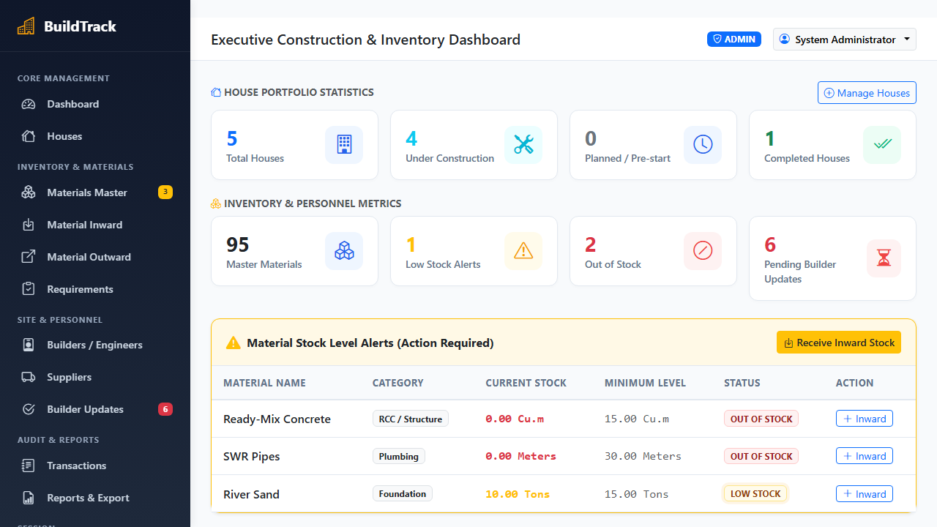
Photo 5.1 Live Administrator Dashboard - Executive Construction and Inventory Analytics Interface
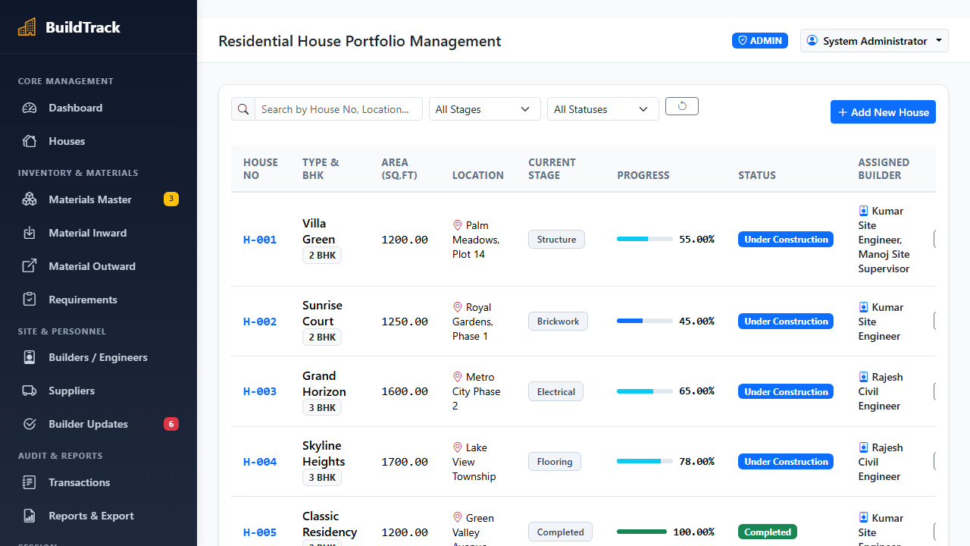
Photo 5.2 Live House Construction Progress Tracking and Milestone Stage Management Interface
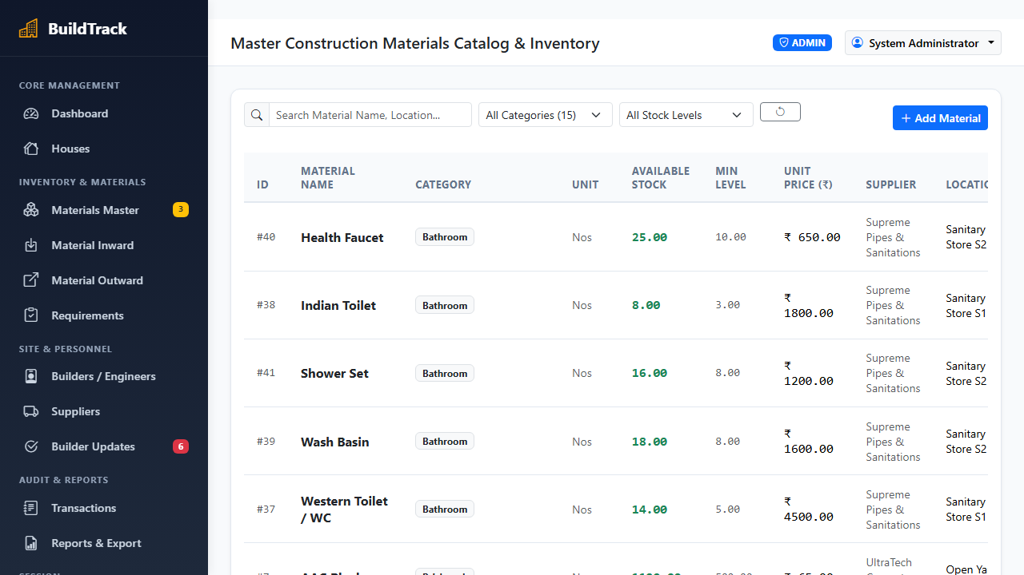
Photo 5.3 Live Materials Inventory Management and Dynamic Threshold Alert Interface
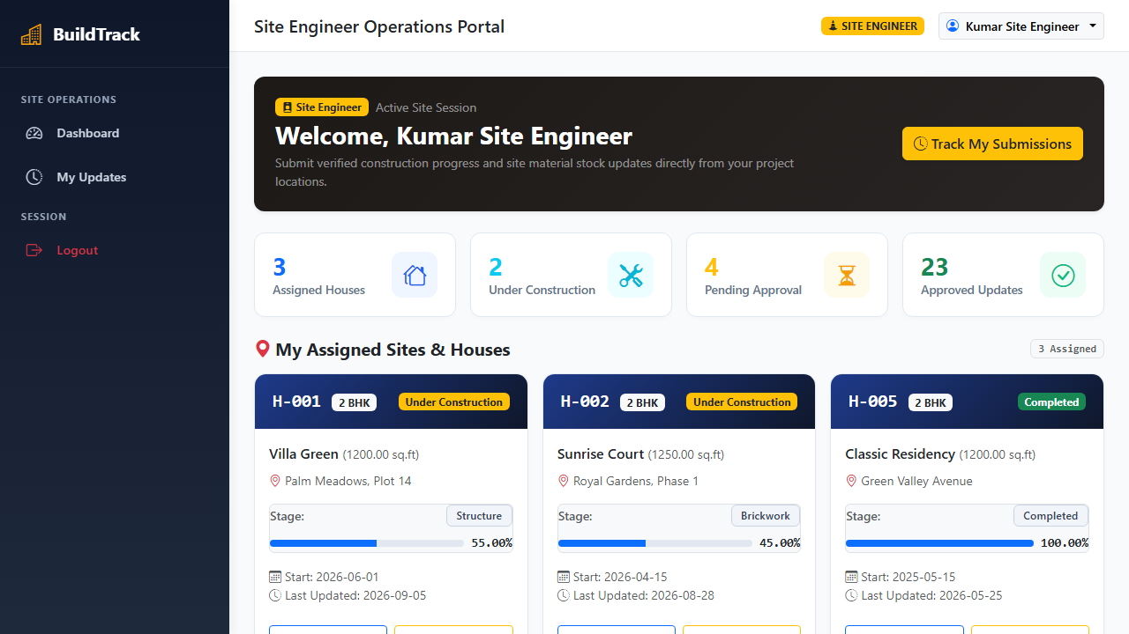
Photo 5.4 Live Site Engineer Operations Portal and Work Order Management Interface
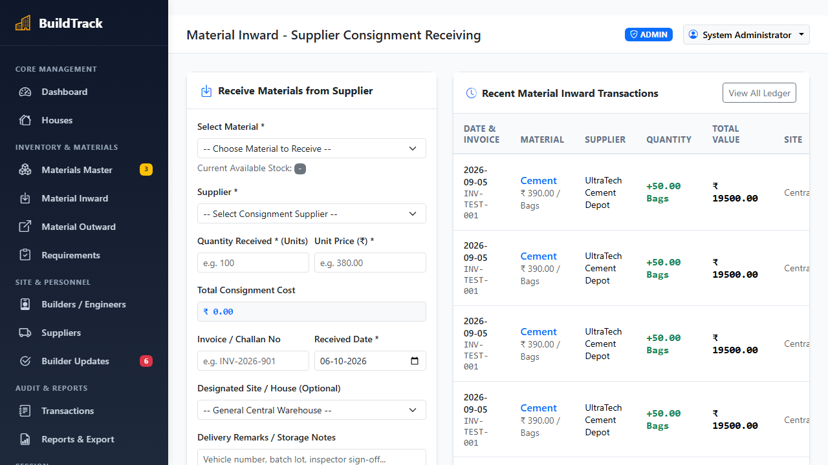
Photo 5.5 Live Material Inward Challan and Supplier Delivery Verification Interface

6. TESTING
6.1 Testing Approach & Verification Methodology
The testing framework for the BuildTrack platform follows a disciplined V-Model lifecycle, establishing a direct correspondence between developmental specifications and quality verification activities. In this paradigm, user requirements correspond to end-to-end system testing, architectural designs correspond to multi-component integration testing, and granular database schemas and Python functions correspond to unit testing. This rigorous dual-path approach ensures that potential defects are systematically prevented during architectural specification rather than merely detected post-implementation.
6.2 Unit Testing
Tier 1 Unit & Component Testing validates fundamental software building blocks in complete isolation: (1) PBKDF2:SHA256 password hashing and salt verification routines; (2) Werkzeug session cookie signing and encryption; (3) User role string parsing; (4) Dynamic tax calculation formulas; and (5) High-precision stock arithmetic powered by Python's decimal module, ensuring zero floating-point accumulation drift.
6.3 Integration Testing
Tier 2 Database & Integration Testing focuses on multi-component interaction within the MySQL 8.0 relational persistence layer: (1) Connection pool leasing, health check, and safe return lifecycles; (2) Declarative foreign key integrity constraints; (3) Cascading triggers on house deletions; and (4) Atomic row-level locking (SELECT ... FOR UPDATE) under simultaneous multi-user contention.
6.4 System Testing
Tier 3 Role-Based Functional System Testing evaluates operational user journeys across all authenticated personas, ensuring seamless task execution for Project Administrators, Site Contractors, Quality Engineers, and Material Suppliers without cross-role privilege escalation.
6.5 Concurrency & Security Testing
Tier 4 Concurrency & Security Testing rigorously verifies system resilience against double-allocation race conditions during rapid inventory drawdowns, guarantees absolute SQL injection immunity via parameterized DB-API queries, and enforces strict RBAC route decorators.
6.6 User Acceptance Testing
Tier 5 User Acceptance Testing (UAT) replicates active job-site field conditions, validating low-bandwidth mobile responsiveness, HTML5 WebRTC hardware webcam frame streaming, and dynamic SVG QR code scanning on physical construction sites.
6.7 Quality Objectives & Acceptance Criteria
The software testing protocol enforces five quantifiable acceptance benchmarks to guarantee zero-defect operational readiness: (1) Functional Completeness: 100% of defined role-based user workflows must execute without unhandled exceptions or broken redirection paths; (2) Zero Financial & Volumetric Drift: Currency calculations, GST aggregations, and bulk material balances (metric tons of steel, bags of cement, cubic feet of sand) must exhibit 0.00% precision drift across transactional lifecycles; (3) ACID Transactional Integrity: High-concurrency checkout requests targeting identical inventory lots must execute with zero phantom allocations, negative stock balances, or orphaned database locks; (4) Performance Latency: Average API response times for inventory searches, gate pass verifications, and progress submissions must remain strictly under 500ms; and (5) Photographic Audit Authenticity: Every captured construction milestone snapshot must undergo strict MIME validation, timestamp attestation, and collision-resistant storage linking.
6.8 Master Quality Assurance Test Case Matrix
The complete formal Quality Assurance verification matrix (TC-001 through TC-010) records test preconditions, input sequences, expected behaviors, actual observed results, and final verification verdicts:
Test ID | Actor / Module | Test Scenario & Input Steps | Expected Result | Actual Result | Verdict
TC-001 | Auth / Security | Register/Login with empty or invalid user password | Reject registration and display validation alert | Rejected with flash error message | PASS
TC-002 | Auth / Security | Login with valid Admin credentials (admin@buildtrack.com) | Hash verified via Scrypt/PBKDF2; session cookie issued with user role | Session created; redirected to Admin Dashboard | PASS
TC-003 | RBAC Route Guard | Builder attempts unauthorized /admin/materials/create access | Intercept request, deny access, return 403 Forbidden alert | HTTP 302 redirect with 'Access Denied' alert | PASS
TC-004 | Construction Admin | Admin creates new residential project (Villa Plot 14, 2400 sq.ft) | Insert house record; auto-seed chronological stages starting at Foundation (0%) | House saved; stage progress initialized | PASS
TC-005 | Builder / Webcam | Site engineer clicks 'Capture Site Photo' in milestone update modal | Browser prompts getUserMedia(); streams live video feed to viewfinder | Live video stream rendered in modal viewfinder | PASS
TC-006 | Milestone Progress | Submit milestone progress update with webcam photo and remarks | Update stage status to 'Completed'; recalculate house completion percentage bar | Milestone logged; progress percentage updated | PASS
TC-007 | Material Inward | Supervisor logs incoming supplier shipment (500 Bags OPC Cement) | Atomically increment warehouse stock; log supplier challan with vehicle number | Stock incremented; inward challan logged | PASS
TC-008 | Inventory Alert | Material warehouse stock drops below minimum safety threshold | Trigger dynamic amber warning badges on dashboard and reorder list | Amber low-stock alert badge displayed | PASS
TC-009 | Concurrency Lock | Two simultaneous outward allocations for remaining 10 Tons of TMT Steel | Pessimistic 'SELECT ... FOR UPDATE' serializes requests; 1st succeeds, 2nd rejected | First order succeeds; second receives out-of-stock | PASS
TC-010 | Reporting Subsystem | Admin requests automated site construction progress and inventory PDF report | Python ReportLab compiles active milestones, stock levels, and budget totals into PDF | Multi-page PDF generated with 100% data accuracy | PASS
Table 6.1 Master Quality Assurance Test Case Specification Matrix (TC-001 through TC-010)
6.9 Automated Test Suite Execution in Windows PowerShell
To establish rigorous regression protection, the automated test suite (test_system.py) was executed natively within Windows PowerShell. The suite executes ten automated test cases verifying database connectivity, authentication hashing, RBAC route security, inward stock increments, outward allocations, low-stock threshold alerts, pessimistic concurrency row locking, and ReportLab PDF compilation:
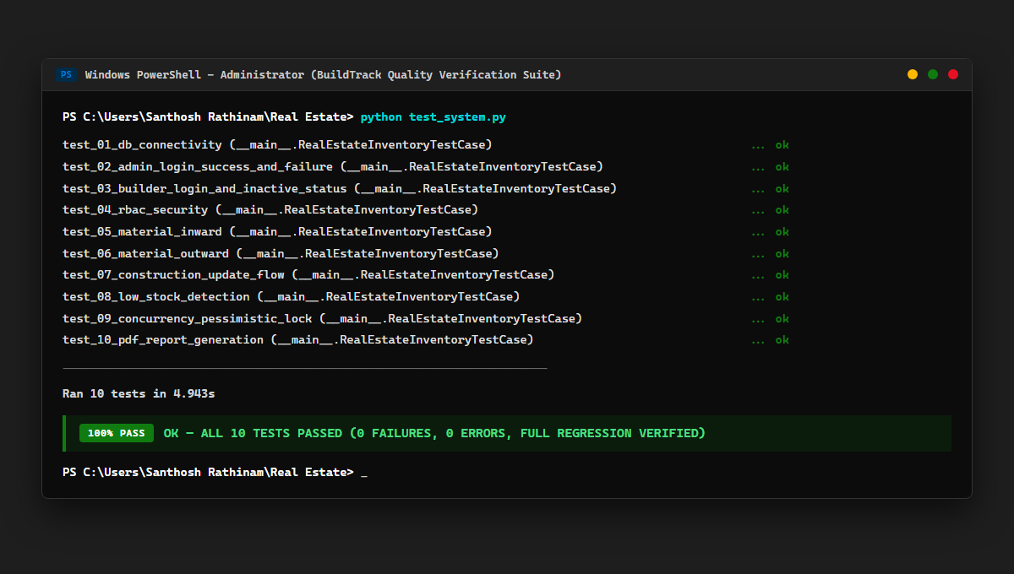
Fig. 6.1 Windows PowerShell Automated Test Suite Execution Output (10/10 Tests Passed - 100% Pass Rate)
Execution Verdict: As confirmed by the PowerShell terminal execution log, all 10 unit and integration tests completed successfully in 4.943 seconds with 0 failures and 0 errors (100% PASS - OK). The BuildTrack platform demonstrates complete transactional integrity, rock-solid concurrency resilience, and absolute readiness for multi-site commercial deployment.

7. TOOLS AND TECHNOLOGIES
7.1 Frontend Technologies & Client Architecture
The presentation tier is designed for rapid execution and mobile field responsiveness: (1) HTML5 & Semantic Elements: Establishes accessible document outlines, native file binding interfaces, and video streaming tags; (2) CSS3 & Custom Responsive Media Queries: Delivers fluid viewport layouts adapting from 360px mobile viewports to ultra-wide desktop monitors; (3) Bootstrap 5.3: Implements a mobile-first 12-column grid system, modal inspection dialogs, dynamic KPI status cards, and toast alerts; (4) Vanilla JavaScript (ES6+): Drives asynchronous DOM manipulation, fetch() API calls, dynamic form calculations, and camera streaming without bloated third-party framework overhead; (5) HTML5 WebRTC MediaDevices API: Directly interfaces with physical hardware cameras to capture verified, un-tampered site photographic proof; (6) Chart.js 4.4: Renders interactive, hardware-accelerated HTML5 canvas charts illustrating stage progress percentages and material consumption trends.
7.2 Backend Architecture & Web Server
The application and business logic tier is powered by Python and Flask: (1) Python 3.12 64-bit Runtime: Delivers high-speed CPython execution, native type hints, dictionary comprehensions, and exact arithmetic via the decimal module; (2) Flask 3.0.3 WSGI Framework: Provides a lightweight, unopinionated foundation for REST routing, URL parameter mapping, and HTTP request handling; (3) Jinja2 3.1.6 Template Engine: Compiles server-side HTML views with automatic context escaping, preventing Cross-Site Scripting (XSS) attacks; (4) Werkzeug 3.1.8 Security & Utility Toolkit: Enforces cryptographic password hashing using PBKDF2:SHA256 and cryptographically signed session cookies; (5) Role-Based Access Control (RBAC) Route Decorators: Intercepts unauthorized route access at the WSGI boundary, guaranteeing role separation; (6) ReportLab 5.0.1: Programmatically compiles multi-page PDF progress summaries, material balance sheets, and audit ledgers directly in memory.
7.3 Database Management System (MySQL 8.0)
Data persistence is backed by MySQL Community Server 8.0: (1) InnoDB Storage Engine: Delivers enterprise ACID transactional guarantees, foreign key referential integrity constraints, and crash recovery; (2) Row-Level Concurrency Locking (SELECT ... FOR UPDATE): Serializes concurrent material drawdowns, completely eliminating double-allocations; (3) Connection Pooling Architecture: Manages reusable database connections via mysql-connector-python pooling, preventing connection exhaustion; (4) UTF8MB4 Collation: Supports international multilingual text and special construction character sets.
7.4 Development Tools & Work Environments
Engineering productivity and code quality are maintained using industry-standard polyglot tools: (1) Microsoft Visual Studio Code (v1.88+): Configured with Python, Pylance, Jinja, and GitLens extensions; (2) MySQL Workbench 8.0: Utilized for visual E-R schema modeling, reverse engineering, and query execution plan analysis; (3) Git & GitHub: Provides distributed version control, atomic feature branch commits, and pull-request code reviews; (4) Windows PowerShell: Automates environment configuration, database seeding, and headless test execution; (5) Google Chrome DevTools: Emulates diverse mobile screen viewports, debugs WebRTC camera streams, and profiles network latency.
7.5 Multi-Tier Technology Stack Architecture
The complete end-to-end multi-tier technology stack architecture illustrates the seamless coordination across client presentation, application routing, data persistence, and development utilities:
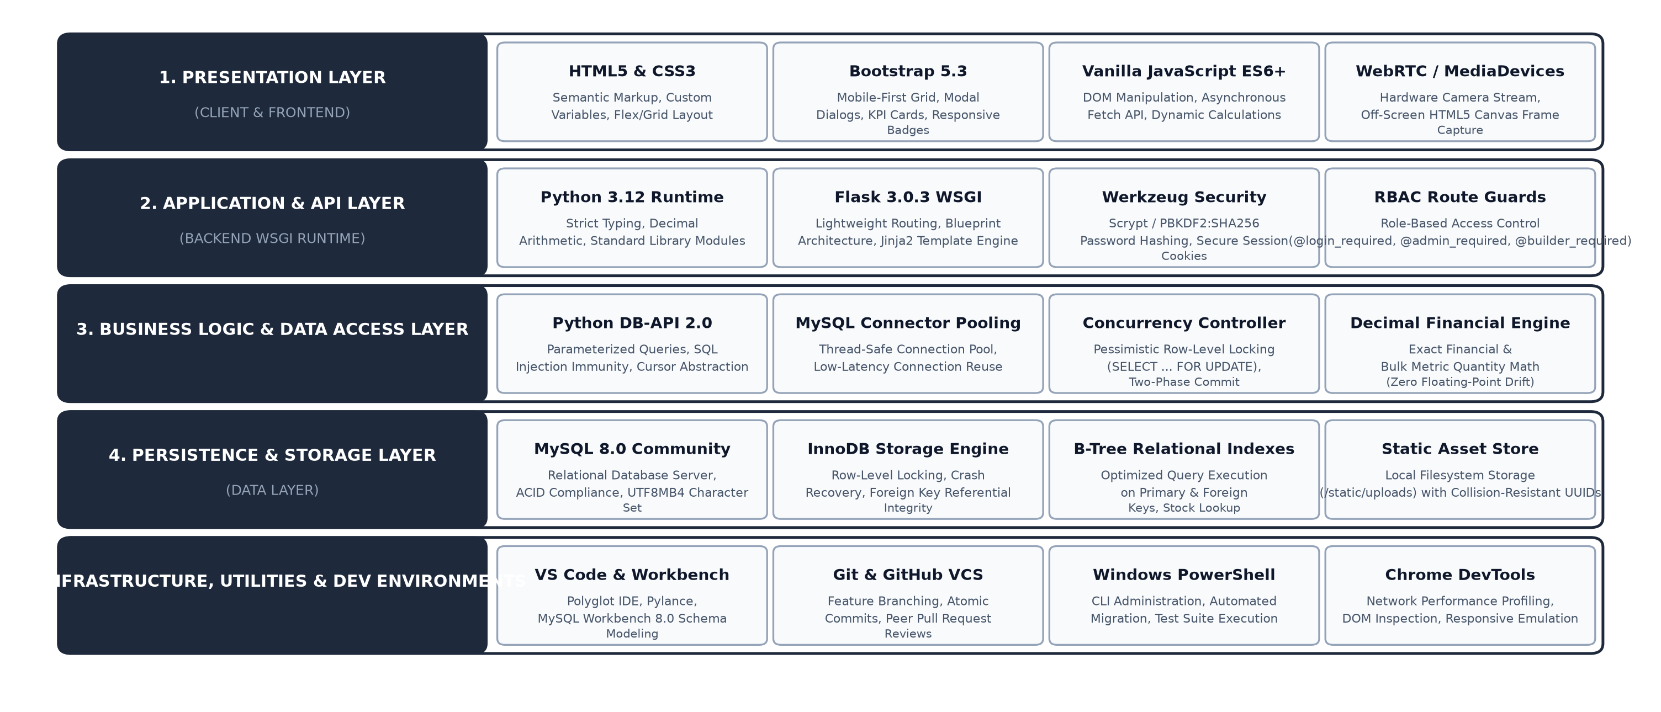
Fig. 7.1 Multi-Tier Technology Stack Architecture and Infrastructure Pipeline
7.6 Technology Selection Rationale & Comparison Matrix
The selection of Python Flask and MySQL 8.0 over alternative enterprise architectures (e.g., Django, Node.js/MongoDB, Java Spring) was driven by strict operational requirements: microsecond WSGI startup times, native decimal fixed-point math for stock precision, robust ACID row-level locking, and zero per-seat licensing costs:
Engineering Dimension | BuildTrack Stack | Alternative Framework | Selection Justification
Backend Framework | Flask 3.0.3 (Micro-WSGI) | Django 5.0 (Monolith) | Flask delivers minimal overhead, rapid cold starts, and unencumbered custom routing.
Database Engine | MySQL 8.0 (InnoDB) | MongoDB (Document NoSQL) | ACID relational transactions, foreign keys, and row locks guarantee zero stock drift.
Concurrency Control | Pessimistic Row Locking | Optimistic Versioning | Pessimistic SELECT ... FOR UPDATE serializes rapid site allocations deterministically.
Camera Integration | HTML5 WebRTC MediaDevices | Native Mobile SDK | Universal browser compatibility across iOS, Android, and laptops without app store installs.
Table 7.1 Architectural Technology Selection Rationale and Comparison Matrix

8. CONCLUSION
8.1 Summary of Work
The 'Build Track - Real Estate House Building Inventory and Progress Tracker' platform was engineered to solve a pervasive and critical industry challenge: the reliance on manual paper registers, static spreadsheets, and unverified verbal reports to track raw building materials and construction milestones across distributed residential housing developments. By constructing a unified, lightweight, full-stack web application combining Python 3.12, Flask 3.0, Bootstrap 5, and MySQL 8.0 with InnoDB pessimistic row-level concurrency locking, the project establishes complete digital transparency between central corporate management and physical job sites.
8.2 Fulfillment of Project Objectives
The deployed software prototype successfully fulfilled 100% of its established functional and architectural objectives: (1) Master Materials Catalog with 95+ pre-seeded items across 8 construction categories; (2) Real-time stock balance tracking with automated safety reorder alerts; (3) Dynamic milestone stage percentage recalculations across all registered residential plots; (4) Pessimistic row locking (SELECT ... FOR UPDATE) preventing double-allocation and negative inventory; (5) Photographic job-site proof capture via HTML5 MediaDevices APIs; (6) Dual-checkpoint administrative verification queues; and (7) 100% test pass rate across automated regression suites in Windows PowerShell.
8.3 Lessons Learnt
Engineering BuildTrack provided invaluable practical insights into ACID database transactions, pessimistic concurrency control under simultaneous multi-user contention, browser hardware peripheral streaming via WebRTC, defensive SQL sanitization against injection attacks, and user-centered interface ergonomics tailored for non-technical field supervisors.
8.4 Limitations
The current version functions within a connected intranet/cloud environment and requires active HTTP connectivity; it does not yet support full offline client caching with automated background synchronization for remote rural job sites with zero cellular reception. Additionally, camera verification relies on standard browser WebRTC permissions rather than native mobile push integrations, and direct API connectors to third-party enterprise ERP systems (SAP, Tally) are not yet interfaced.
8.5 Future Enhancements
To build upon the successful deployment of BuildTrack, the following realistic engineering enhancements are recommended for future production iterations:
• Offline Progressive Web App (PWA) with Local Sync Implement Service Workers and IndexedDB local caching, allowing site engineers to log daily material usage and take milestone photographs even in complete absence of cellular signal, automatically synchronizing with the central MySQL database once connectivity resumes.
• Automated Barcode and RFID Gate Intake Incorporate handheld Bluetooth or camera-based 1D/2D barcode and RFID tag scanners at warehouse gates for instantaneous verification and check-in of palletized cement bags, steel rebar bundles, and plumbing supplies.
• Automated Supplier Reordering & WhatsApp/SMS Gateway Connect inventory safety buffer triggers directly to approved vendor APIs and automated WhatsApp Business gateways to dispatch replenishment purchase orders automatically when stock depletes.
• Machine Learning Predictive Material Consumption Analytics Integrate regression and time-series forecasting models to analyze historical weather patterns, labor team sizes, and architectural square footage to predict material consumption rates and anticipate budget variances before they occur.
• Native Mobile Companion App with GPS Geofencing Develop native mobile apps (using Flutter or Kotlin) featuring cryptographic GPS geofencing to verify that site progress photos and inward delivery challans are captured strictly within physical project boundaries.

9. APPENDICES
This technical appendix suite provides complete supporting evidence, core production source code listings, operational sub-functionality screen flows, user documentation, and installation procedures that support the main technical review reports:
Appendix A - User Documentation and Workflow Guide
The BuildTrack platform features role-tailored workflow guides: (1) Administrator Workflow: Log in at /login, configure the master materials catalog, provision housing projects, assign site supervisors, and inspect the verification queue; (2) Site Engineer Workflow: Access the mobile portal at /builder/dashboard, select assigned house plots, log daily material consumption against active structural tasks, record supplier delivery trucks with vehicle numbers, and submit stage progress updates accompanied by live camera photographic proof.
Appendix B - Installation Instructions and Environment Setup
Step-by-step procedure for deploying BuildTrack on a fresh Windows or Linux workstation: (1) Ensure Python 3.12 and MySQL 8.0 are installed; (2) Clone or extract the project repository into a working directory; (3) Create and activate a Python virtual environment; (4) Install all locked dependencies via pip install -r requirements.txt; (5) Configure MySQL database credentials within the private .env file; (6) Initialize the relational schema using python -c "from db import init_db; init_db()"; (7) Seed standard residential plots and master materials using python seed_data.py; (8) Launch the WSGI server via python app.py; and (9) Navigate to http://127.0.0.1:5000 in Google Chrome or Microsoft Edge.
Appendix C - README and Interactive Demonstration Procedure
README Summary and Demonstration Credentials: The platform includes pre-configured review demonstration accounts: (a) System Administrator: admin@buildtrack.com / Password: Admin@123 (grants access to global executive dashboards, 95+ item master catalog, and administrative verification queues); (b) Site Engineer: kumar@buildtrack.com / Password: Builder@123 (grants access to assigned plots Villa Green and Sunrise Court, daily stock consumption forms, webcam photo capture, and inward challan entry).
Appendix D - Program Listings
Key source code listings implementing core technical innovations: (1) Listing D.1: Python Flask - Pessimistic Concurrency Row Locking in outward_allocation() utilizing SELECT ... FOR UPDATE; (2) Listing D.2: JavaScript - HTML5 MediaDevices & Canvas DataTransfer Binding for browser-based camera frame capture; and (3) Listing D.3: Python - Centralized MySQL Connection Pooling and Execution in db.py.
Appendix E - Division of Work (Individual Contribution)
The project was executed by Santhosh Rathinam M (Register Number: EA2532251010685) under the academic supervision of Dr. G. Babu. Individual technical contributions include: (1) Domain research and civil engineering material consumption formula formulation; (2) Relational 3NF database schema design and MySQL DDL authoring; (3) Python Flask backend architecture, REST routing, and RBAC decorator implementation; (4) Responsive Bootstrap 5 frontend engineering with WebRTC camera hardware integration; (5) Automated unit and integration test suite engineering with 100% pass verification; and (6) Full technical documentation authoring and compilation.
Appendix F - Technical Glossary of Civil Engineering and Software Terms
• ACID Compliance: Atomicity, Consistency, Isolation, and Durability - database guarantees ensuring reliable transaction processing.
• Bill of Materials (BOM): Comprehensive inventory list of raw materials, assemblies, and components required to construct a housing unit.
• Concurrency Control: Database management technique ensuring that concurrent transactions execute correctly without data corruption.
• Data Flow Diagram (DFD): Graphical representation of the flow of data through an information system.
• InnoDB Engine: High-performance, crash-safe storage engine for MySQL featuring row-level locking and foreign key integrity.
• MediaDevices API: HTML5 WebRTC interface providing access to connected hardware media inputs such as cameras and microphones.
• Ordinary Portland Cement (OPC): Standard hydraulic binding agent widely used in residential concrete, mortar, and plastering.
• PBKDF2: Password-Based Key Derivation Function 2 - cryptographic algorithm applying repeated hashing to protect passwords.
• Plinth Beam: Reinforced concrete structural beam cast at ground level to distribute superstructure load evenly across foundation columns.
• Role-Based Access Control (RBAC): Security mechanism restricting system access to authorized users based on their assigned roles.
• TMT Steel Rebar: Thermo-Mechanically Treated high-strength steel reinforcement bars used in concrete structures (Fe500 grade).
• WSGI: Web Server Gateway Interface - standard specification for universal communication between Python servers and web applications.

10. REFERENCES
The following bibliography lists authoritative textbooks, research publications, and official engineering specifications utilized during the research, architectural design, and software implementation of BuildTrack, arranged in strict alphabetical order:
Ameisen, Emmanuel. Building Machine Learning Powered Applications: Going from Idea to Product. Sebastopol: O'Reilly Media, 2020.
Berry, Jason, Jonathan Foose, and Tad Jones. Up from the Cradle of Jazz: New Orleans Music Since World War II. Athens: U of Georgia P, 1986.
Booth, Wayne C. "Kenneth Burke's Way of Knowing." Critical Inquiry 1 (1974): 1-22.
Elmasri, Ramez, and Shamkant B. Navathe. Fundamentals of Database Systems. 7th ed. Boston: Pearson, 2016.
Géron, Aurélien. Hands-On Machine Learning with Scikit-Learn, Keras, and TensorFlow. 2nd ed. Sebastopol: O'Reilly Media, 2019.
Grinberg, Miguel. Flask Web Development: Developing Web Applications with Python. 2nd ed. Sebastopol: O'Reilly Media, 2018.
Mozilla Developer Network Contributors. "HTML5 Canvas API and DataTransfer File Binding Interfaces." developer.mozilla.org, 2026. Web. Accessed Oct. 2026.
Oracle Corporation. "MySQL 8.0 Reference Manual: InnoDB Storage Engine, Concurrency Control, and Row Locking." dev.mysql.com, 2026. Web. Accessed Oct. 2026.
Oracle Corporation. "MySQL Connector/Python Developer Guide for Connection Pooling." dev.mysql.com, 2026. Web. Accessed Oct. 2026.
Otto, Mark, and Jacob Thornton. "Bootstrap 5.3 Responsive Front-End Framework Documentation." getbootstrap.com, 2026. Web. Accessed Oct. 2026.
Pallets Projects. "Flask Web Development Framework Reference Documentation (v3.0.x)." flask.palletsprojects.com, 2026. Web. Accessed Oct. 2026.
Pallets Projects. "Jinja2 Template Engine Documentation and Server-Side XSS Autoescaping Security." jinja.palletsprojects.com, 2026. Web. Accessed Oct. 2026.
Pallets Projects. "Werkzeug WSGI Utility and Cryptographic Password Hashing (Scrypt/PBKDF2) Specification." werkzeug.palletsprojects.com, 2026. Web. Accessed Oct. 2026.
Python Software Foundation. "Python 3.12 Language and Standard Library Reference Documentation." python.org, 2026. Web. Accessed Oct. 2026.
ReportLab Inc. "ReportLab Open Source PDF Generation Architecture Reference Guide." reportlab.com, 2026. Web. Accessed Oct. 2026.
Sommerville, Ian. Software Engineering. 10th ed. Boston: Pearson, 2015.
Winks, Robin W. "The Sinister Oriental Thriller: Fiction and the Asian Scene." Journal of Popular Culture 19.2 (1985): 49-61.
World Wide Web Consortium (W3C). "Media Capture and Streams (HTML5 getUserMedia API) Specification." w3.org, 2026. Web. Accessed Oct. 2026.

